LENSES & OPTICS OF THE EYE

**Credits:** Adaptation by Annette Lopez, Roger Key, Sarah Kroeker, California State University, Fresno Physics Dept.

**Background:**

Read the introduction on page 79 of your paper lab manual. View these introductory videos:

* Crash Course Physics: <https://youtu.be/Oh4m8Ees-3Q>
* Bill Nye: <https://youtu.be/MvUIsetjVck>

**PART I: Lenses**

We will be using a simulation environment from oPhysics similar to the one use in Lab 08, however this time we have **lenses** instead of **mirrors**:

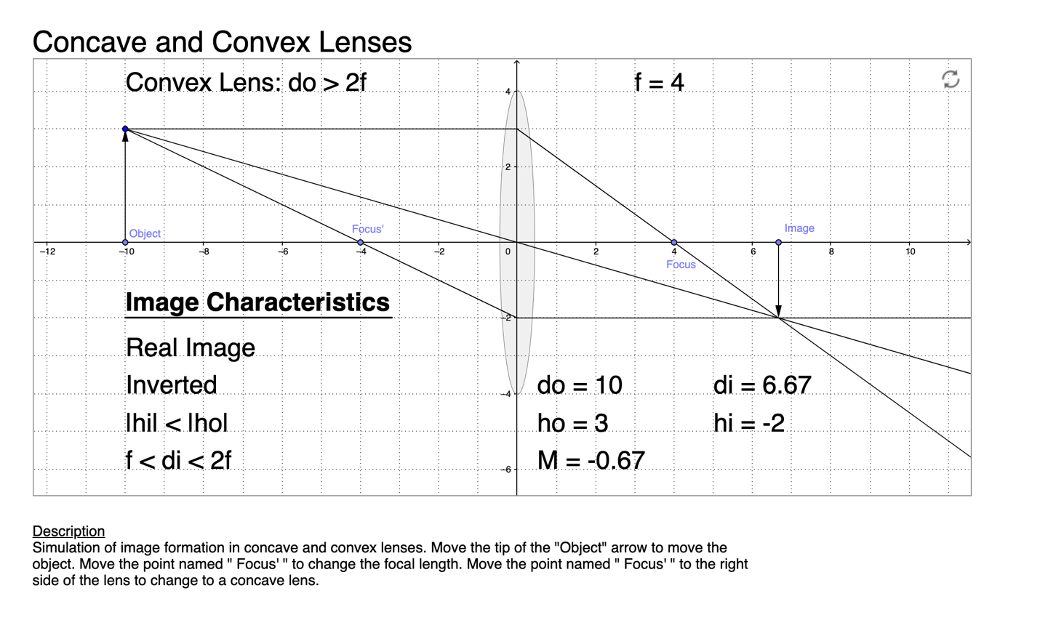

Link to simulation: <http://ophysics.com/l12.html>

**Instructions:**

For scale, each box will represent 1 cm. Use these units for your calculations.

**For converging lenses (Convex), the focal length is always positive, while diverging (Concave) lenses always have negative focal lengths**. Keep this in mind when doing your calculations. Also, when doing your calculations always make the given values of the **object distance positive**, they are written as negative to mimic the simulation.

Move the tip of the "Object" arrow/the blue circle to move the object.

**Make a note of the time when you are beginning this activity. Later, we want to know how much time you spent doing this activity.**

**Convex Lens**  *The Focus’ point should be to the left of the lens.*

1. Without the simulation, calculate the image position, height, and magnification for the following situation:

Focal length (f’) = -4 (+4 in your calculations)

Object distance (do) = –10 (+10 in your calculations)

Object height (ho) = 2 boxes

Is the image real or virtual, is the image inverted or upright?

[insert your answer here]

1. In oPhysics (the simulation): Position the focus and object on the simulation to match the initial conditions in the previous question. Confirm that your answers were correct. If not, check your calculations. Reproduce the diagram below.

[insert your answer here]

1. Without the simulation, calculate the image position, height, and magnification for the following situation:

Focal length (f’) = -4 (+4 in your calculations)

Object distance (do) = –6 (+6 in your calculations)

Object height (ho) = 2 boxes

Is the image real or virtual, is the image inverted or upright?

[insert your answer here]

1. In oPhysics (the simulation): Position the focus and object on the simulation to match the initial conditions in the previous question. Confirm that your answers were correct. If not, check your calculations. Reproduce the diagram below.

[insert your answer here]

**Concave Lens**

*The Focus’ point should be to the right of the lens.* *You should see the lens shape change.*

1. Without the simulation, calculate the image position, height, and magnification for the following situation:

Focal length (f’) = +4 (-4 in your calculations)

Object distance (do) = –10 (+10 in your calculations)

Object height (ho) = 2 boxes

Is the image real or virtual, is the image inverted or upright?

[insert your answer here]

1. In oPhysics (the simulation): Position the focus and object on the simulation to match the initial conditions in the previous question. Confirm that your answers were correct. If not, check your calculations. Reproduce the diagram below.

[insert your answer here]

1. Without the simulation, calculate the image position, height, and magnification for the following situation:

Focal length (f) = +4 (-4 in your calculations)

Object distance (do) = –6 (+6 in your calculations)

Object height (ho) = 2 boxes

Is the image real or virtual, is the image inverted or upright?

[insert your answer here]

1. In oPhysics (the simulation): Position the focus and object on the simulation to match the initial conditions in the previous question. Confirm that your answers were correct. If not, check your calculations. Reproduce the diagram.

[insert your answer here]

**PART II: Optics of the Eye**

**Background:**

Read the introduction on page 97-100 of the lab manual. Ignore the last section titled “The Human Eye Model.”

You can also view this introductory video

<https://youtu.be/PuCQd5_WUR4>

Link to simulation: <http://ophysics.com/l16.html>

1. Place the slider for “Overlay Eye Anatomy” at the midway point.
2. Read the description below the simulation, but take no action yet.
3. Note, “When the refracted rays in the eye come together on the retina, the image is in focus.”
4. Slide the “Focus” of the eye to a point where the image is focused on the retina. Record here the position of the “Focus” and the “Object Position” sliders when the image is focused.

[insert your answer here]

1. What did the lens in the eye do when this adjustment was made? (did the focal length of the lens become shorter or longer?) Why?

[insert your answer here]

1. Now move the slider for the “Object Position” to the near point. You should see that the image is no longer focused on the retina. Move the slider for “Focus” to a place where the image is again focused on the retina. What is the response of the lens in the eye? Does the focal length of the lens in the eye get shorter, or longer? Why?

[insert your answer here]

1. Now set the object position halfway between “near” and “far” … adjust the focus of the eye lens so the image is focused on the retina. How did the focal length of the eye lens change? Why?

[insert your answer here]

1. The sequence you just finished replicates the normal performance of the eye known as **accommodation**. When the lens won’t focus properly, a person can be “nearsighted” or “farsighted.” To simulate these conditions, do the following.
2. Near and Far sightedness:
   1. With the checkbox for “Normal Vision” checked, adjust both the “Focus” and the “Object Position” to the “Far” setting. You should see this:

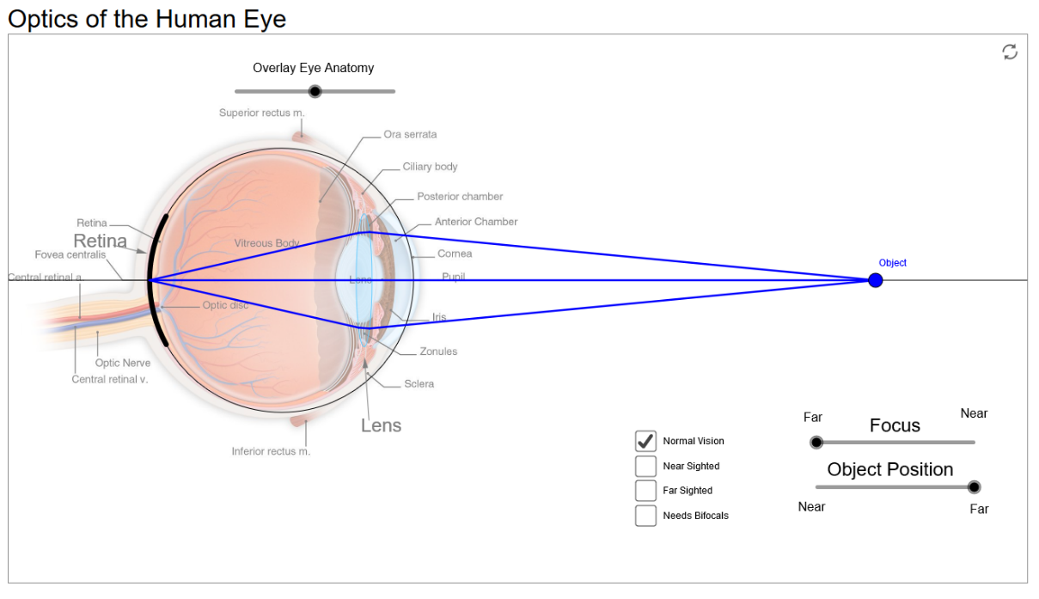

* 1. Now click the box marked “Near Sighted”
  2. Does the focal length of the eye lens get shorter, or longer? Why?

[insert your answer here]

* 1. Now click the check box in the upper right corner of the simulation “Correct Nearsightedness.” Explain how the addition of an external lens corrects for nearsightedness.

[insert your answer here]

* 1. Now, click the checkbox for “Far Sighted” at the bottom center of the simulation. Is the image focused now? (the sliders for “Focus” and “Object position” should be at the “far” positions)
  2. Slide both “Focus” and “Object Position” sliders to the “Near” position. Is the image focused now? Explain. Is the focal point in front of, behind, or on the retina? Why?

[insert your answer here]

* 1. Now click the check box for “Correct Farsightedness” in the upper right corner. Explain how the addition of an external lens corrects for farsightedness.

[insert your answer here]

1. Now put both “Focus” and “Object Position” sliders to the “Far” position.
2. Click the “Needs Bifocals” checkbox. How did the focal point of the eye lens change? This simulates a condition known as presbyopia. (<https://en.wikipedia.org/wiki/Presbyopia>)

[insert your answer here]

* 1. Slide the “Focus” adjustment … can you ever achieve a point where the image is in focus?

[insert your answer here]

* 1. Click the checkbox “Correct Nearsightedness” in the upper right corner. Explain how the new external lens corrects vision.

[insert your answer here]

1. Write a summary of what you have learned (at least one paragraph).

[insert your answer here]

1. Do Procedure Part 5: Blind Spot on page 105 of your paper lab manual. Record your observations.

[insert your answer here]

**Post-Lab Feedback:** Record the amount of time it took you to complete this lab activity, and describe whether any of the technology or instructions were unclear. What do you think we can do to make this activity better?

[insert your answer here]